# Lab 12: Create hands of cards

Academic Honesty

* The work you turn in is to be your work, not copied from someone else, from the web, or generated by a program.
* Never allow anyone access to your files.
* Never give anyone your password.
* Never share your USB memory or email your files to anyone else.
* Never give anyone a printed copy of your file or an electronic copy.
* Never allow anyone to copy your work.

Purpose

This lab will let us practice calling functions are receiving data back from them.

## Functionality

* Your program will create and display 4 hands of cards.

## Implementation

* Create 2 arrays
  + 1 holds the suites (Diamonds, Hearts, Clubs, Spades)
  + 1 holds the face (Ace, King, Queen, Jack, 10, 9, 8, 7, 6, 5, 4, 3, 2, 1)
* Create a function to create a card
  + Pick a random face and suite from the arrays, and return the string representation of the card, e.g. “7 of Clubs”
* Create a function to display a hand of cards
  + Loop 4 times
    - Call the function which creates a card, and display the card
* Using a loop, call the function to display a hand of cards 4 times, to achieve output like the sample program

## Sample Program

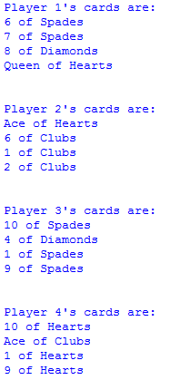

## Submitting your files

* Copy your .py file and move it to your X:\101Labs directory for grading.
* Make sure your file is named Lab12XY.py where XY are your initials
* Print your code, and submit it to your lab instructor at the beginning of your next lab class.

## Grade Breakdown

|  |  |
| --- | --- |
| **Points** | **Expectation** |
| 10% | Comments, listing program, your name, and explaining the code |
| 30% | Create card function: properly creates and returns a random card. |
| 30% | Create hand function: properly loops and calls the create card function, display the hand |
| 15% | Creating the arrays |
| 15% | Calling the create hand function to display the 4 hands |